1. **LIBRARY MANAGEMENT SYSTEM**

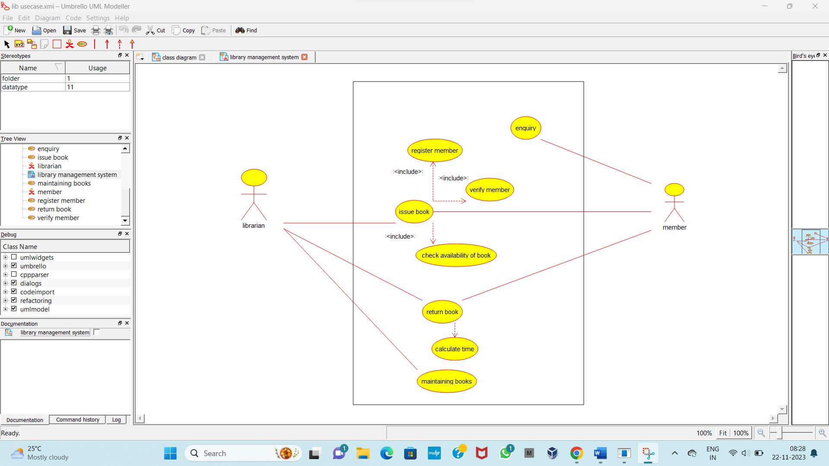

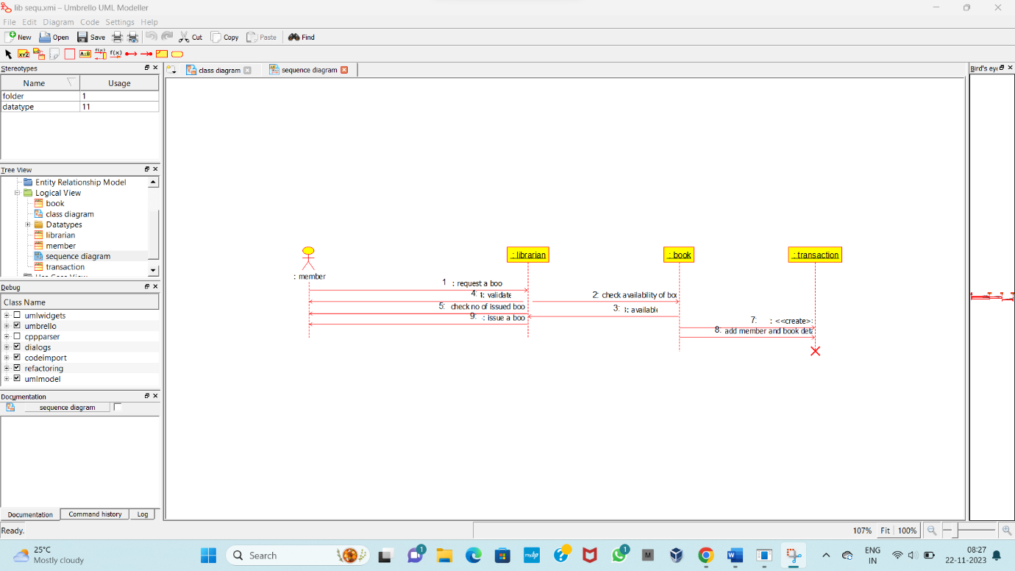

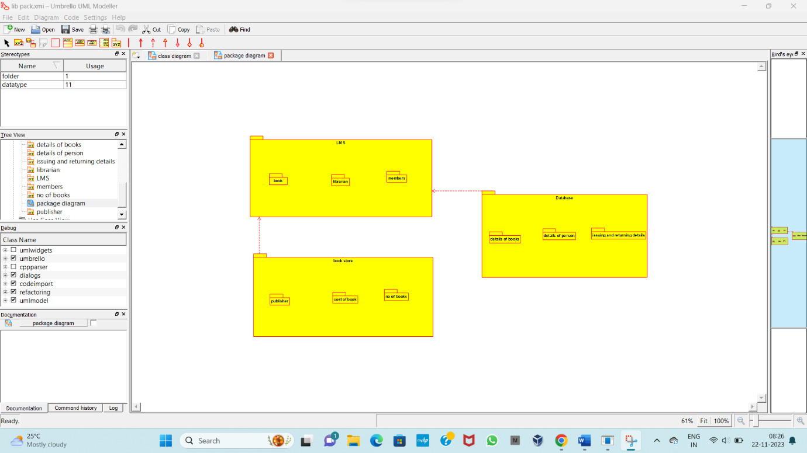

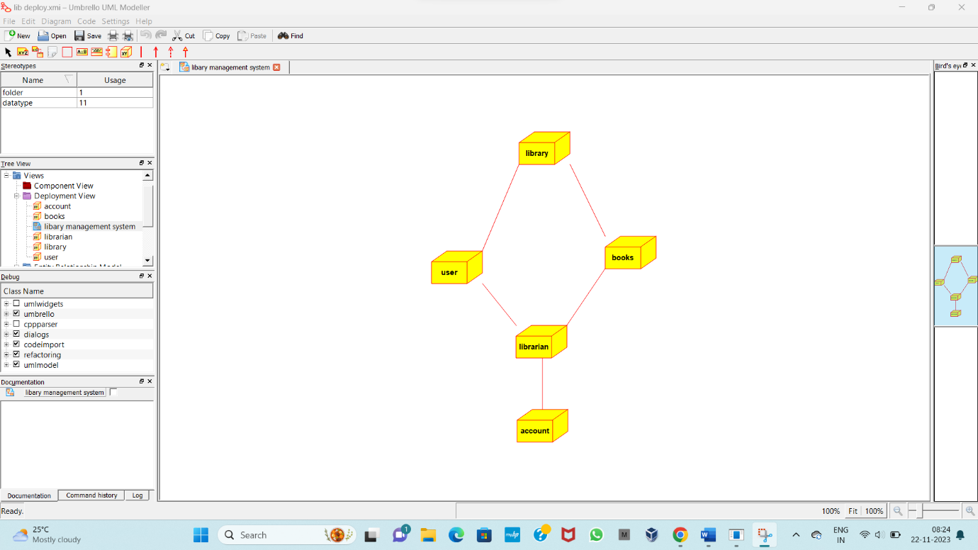

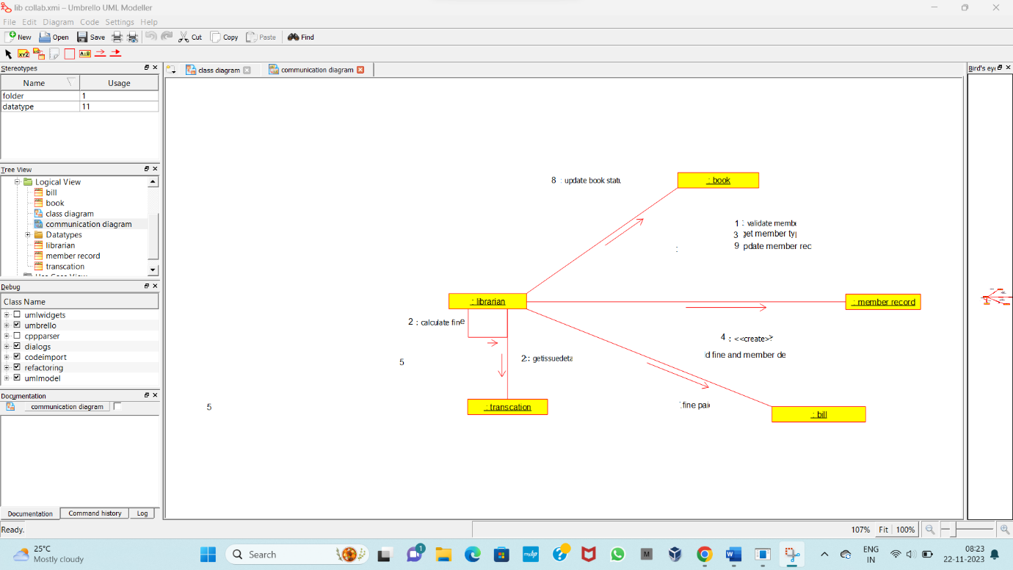

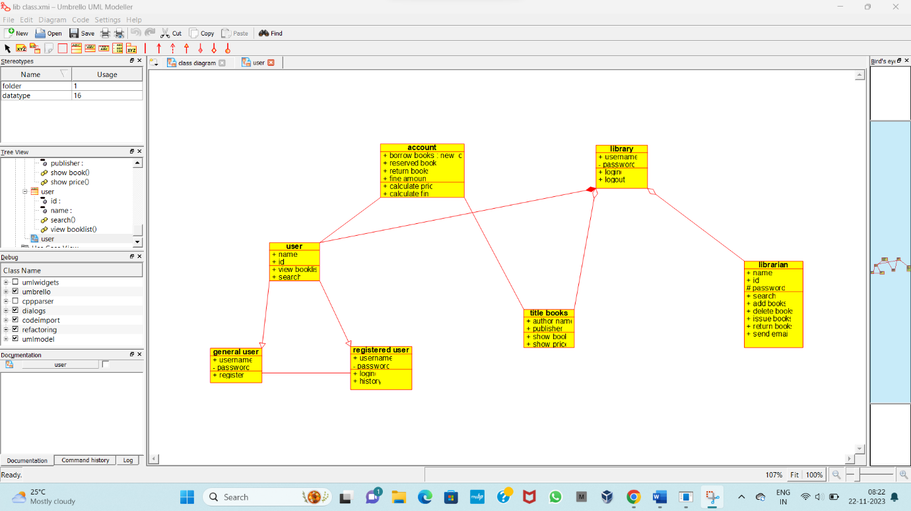

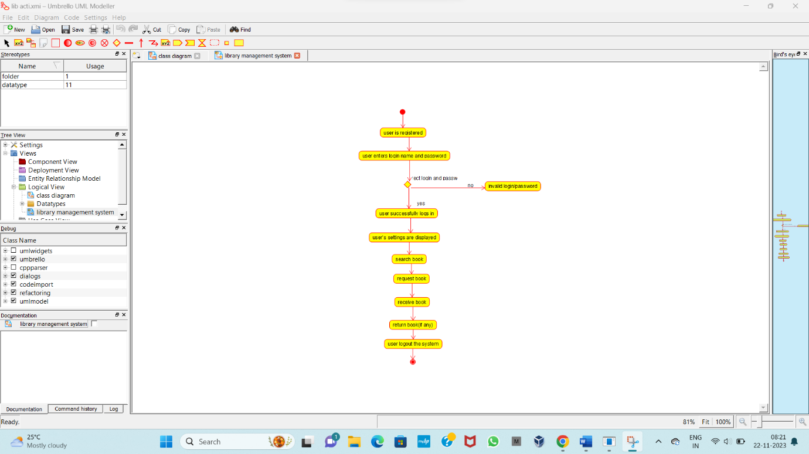

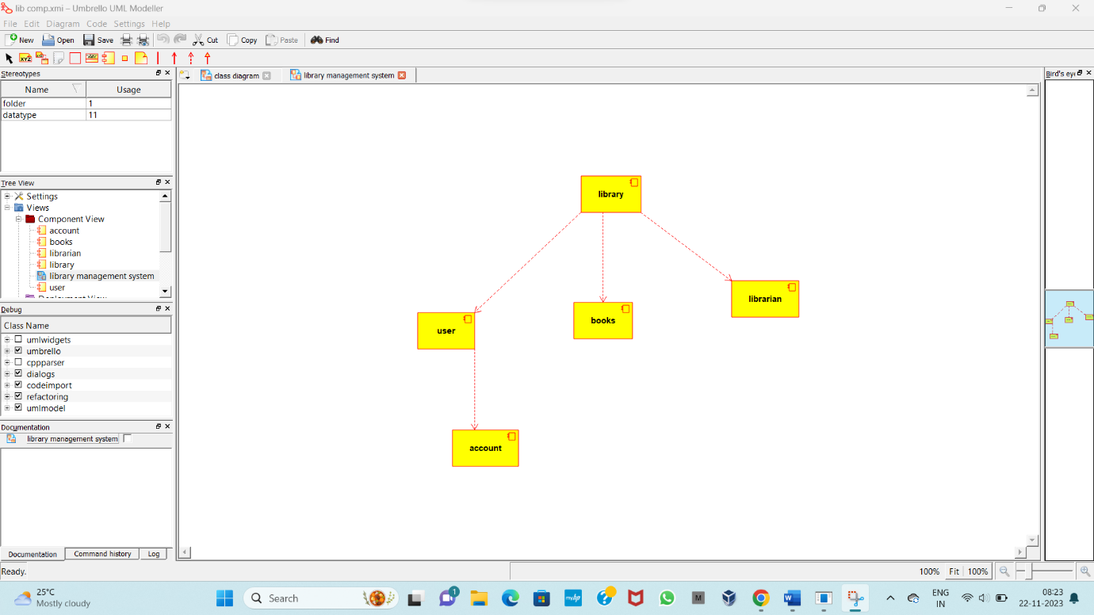

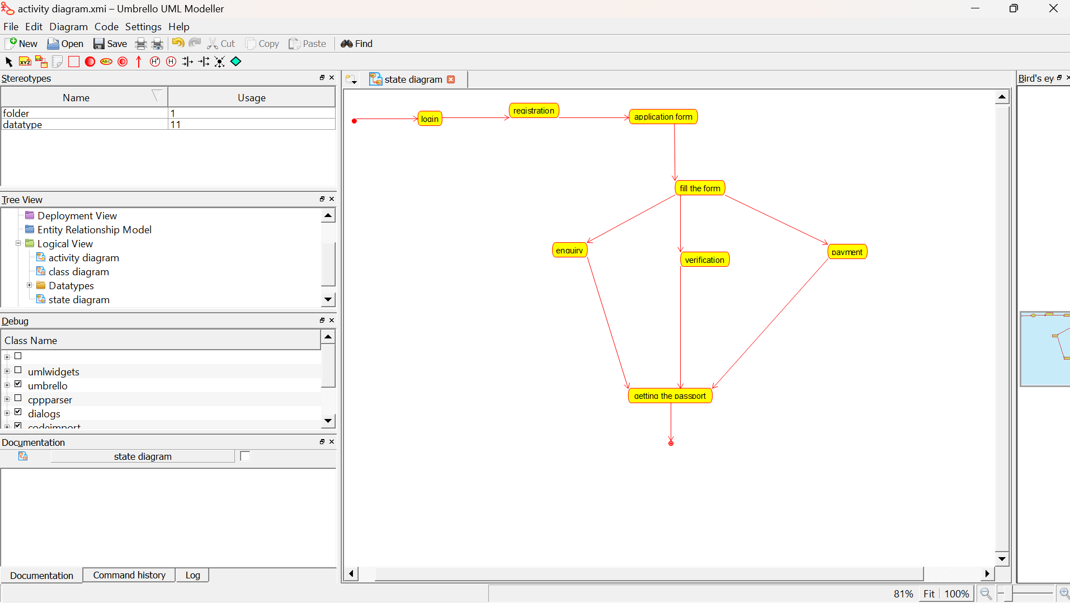

**CODE SKELETON**

**# coding=System**

**from user import \***

**from title_books import \***

**from librarian import \***

**class library(object):**

**"""**

**:version:**

**:author:**

**"""**

**""" ATTRIBUTES**

**username (public)**

**password (private)**

**"""**

**def login(self):**

**"""**

**@return :**

**@author**

**"""**

**pass**

**def logout(self):**

**"""**

**@return :**

**@author**

**"""**

**pass**